

**Project Report**

Course Title: Smartphone Application Development

Course Code: CSE 438

Section: 01

Session: Fall 2023

**Prepared for**

Mr. [Shakib Mahmud Dipto](mailto:shakib.mahmud@ulab.edu.bd)

Lecturer

Department of Computer Science and Engineering

University of Liberal Arts Bangladesh

**Prepared by (Group 13)**

Md.Mohi Uddin Ahmed (201014091)

[Md.Shaiful Islam Shaishob (201014107)](mailto:shaiful.islam.cse@ulab.edu.bd)

**Software Requirements Specification (SRS)**

**1.Introduction**

1.1 Purpose:

Plant App - is an app that every plant lover will be benefited by buying and selling plants . This app will help people to buy, sell, manage and take care of plants. The purpose of this app we develop is to reach plants to the users in the easiest way so that they can utilize our Plant App effectively.

1.2 Scope:

Users can buy their required plant from this app and it is less time consuming because the plant you order from the app, will be delivered to your home. You don't need to go to the nursery to buy trees, seeds and other accessories. This app also gives you tips to manage and take care of your plants.

**2.Functional Requirements**

2.1 User Registration & Authentication:

* Users can log in via e-mail address or logging in with their social media accounts, if users don't have any id then users can quickly create an account on the system. The system will function without issue once you register.
* User authentication will be implemented using a common username and password mechanism to guarantee secure access to the system.

2.2 Update Plants:

* Users can update their plants with the help of a modification tool.
* Users will be able to add plants to their profile.
* Before making a purchase, users will be able to save and preview their ordered plants.

2.3 Plant Ordering:

* Users ordering plants will be updated and included in the cart.
* The system must calculate and display the total cost of all items in the cart.
* Users will be able to add more items or remove items from the cart.

2.4 User Profile Management:

* Users must have access to and the ability to edit their profile information.
* Users can add their favorite plant to their profile.
* Users can log out from their account.

**3.Non-Functional Requirements**

3.1 Performance:

* The system responds quickly.
* This app must provide a responsive and enjoyable user experience.

3.2 Security:

* It must be secured to users by adding a password.
* The system encrypted sensitive data and user accounts.

3.3 Maintainability:

* This application would not need any servicing.

3.4 Availability:

* This system only be usable until it operates on the system it is built on.

3.5 Useability:

* The user interface has excellent usability.

3.6 Scalability:

* Applicable.

**4.Constraint**

* This is an android application.
* The system is developed by Dart.

**Class Diagram**

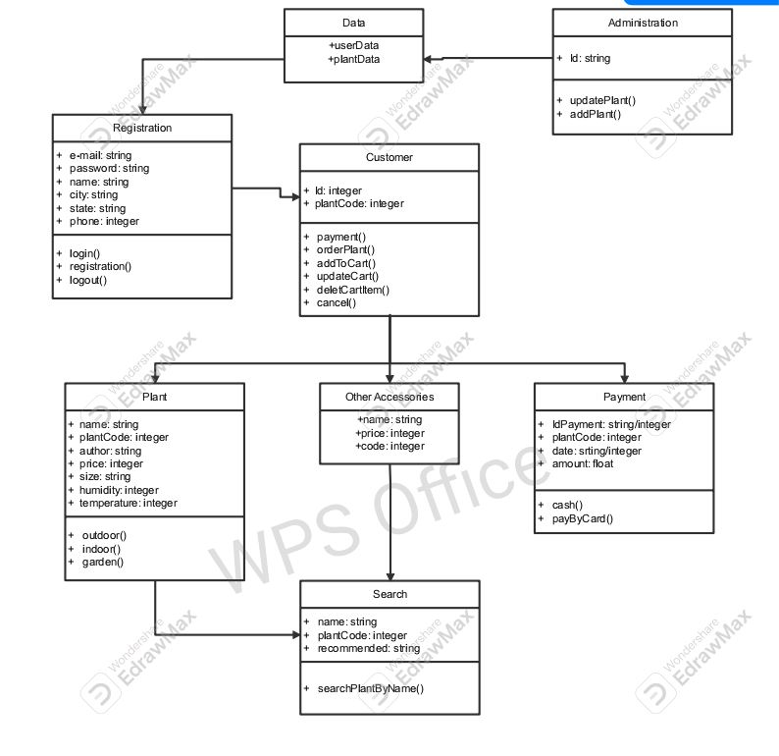

**Outlines**

* Onboarding Screen
* User sign in / sign up
* Home page
* Categories
* Search bar
* Details
* Cart
* Tips & tricks
* Favorites
* Profile

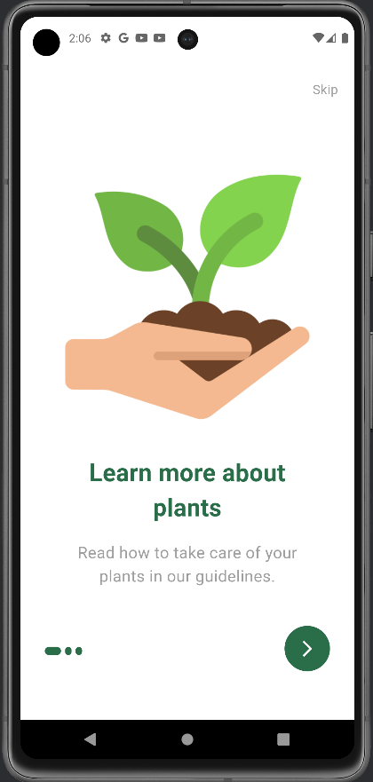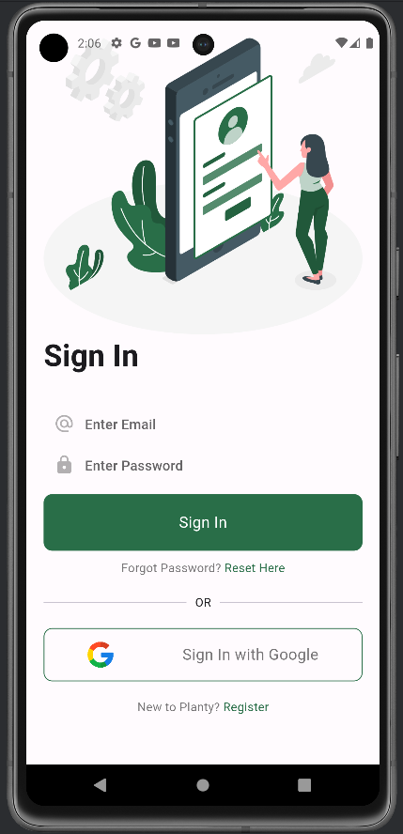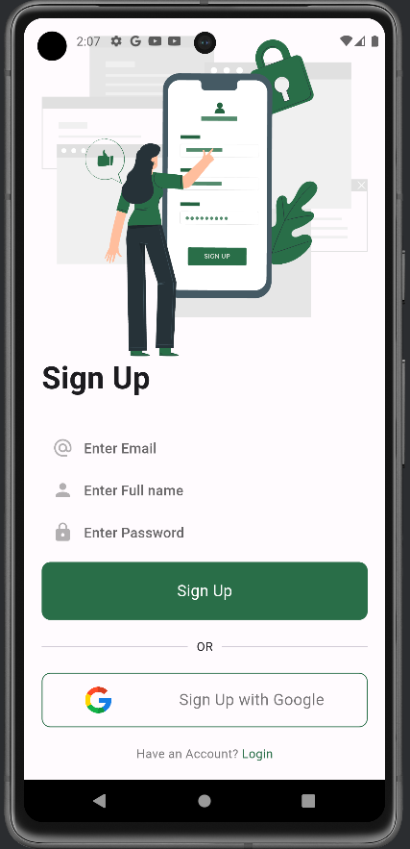

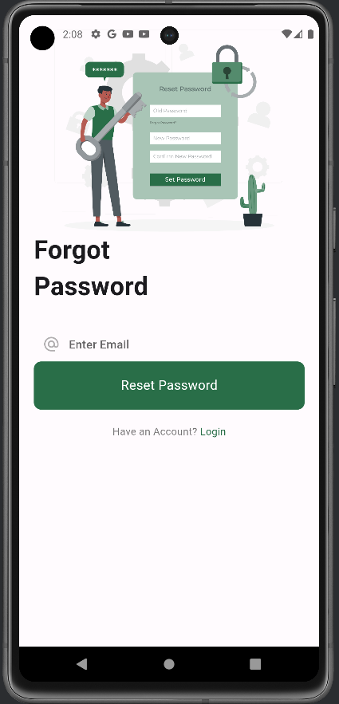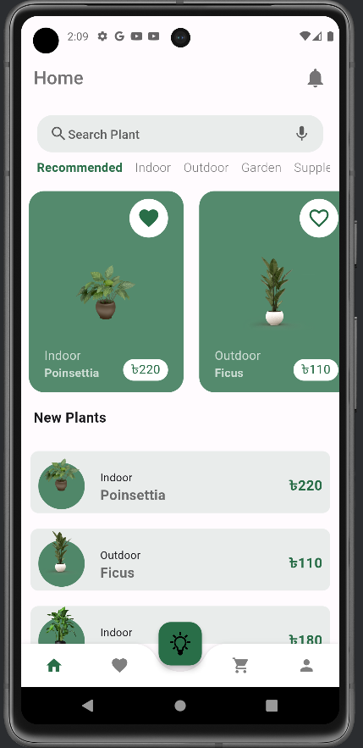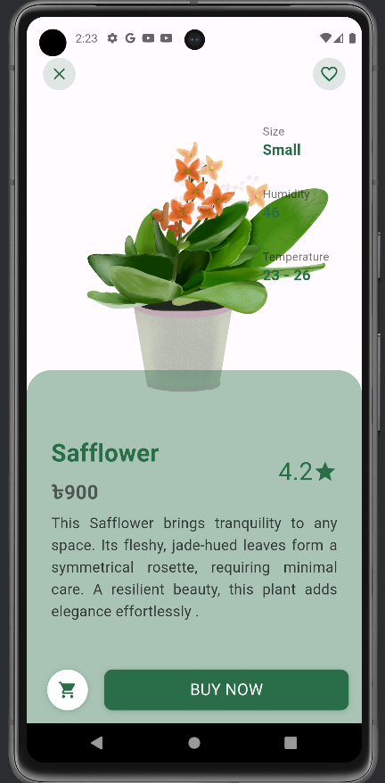

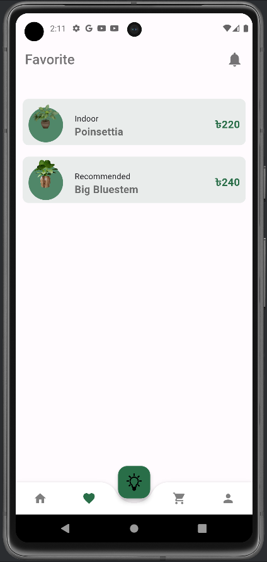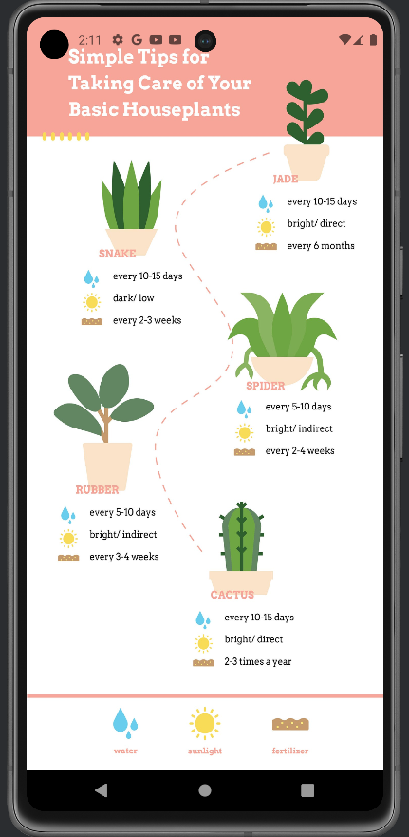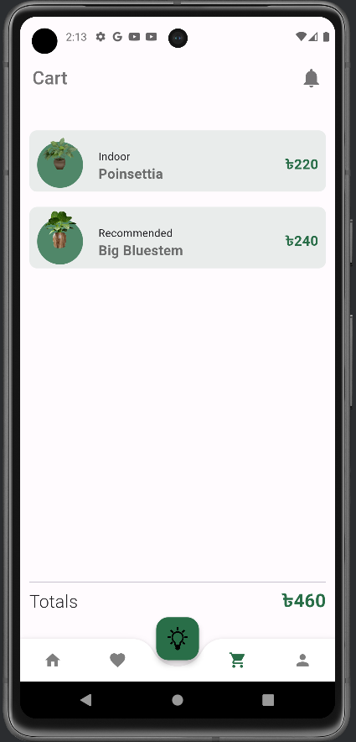

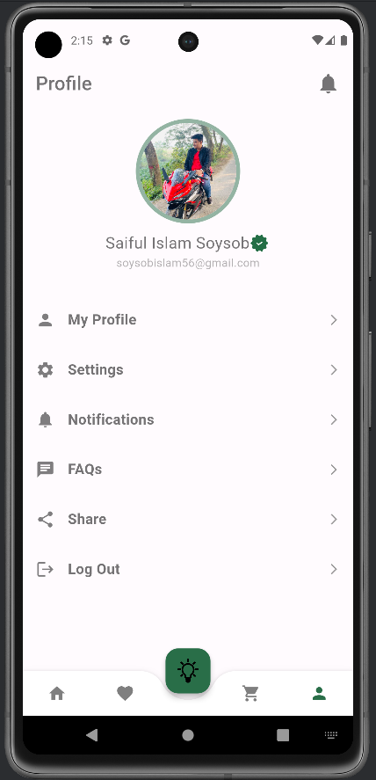

**Code**

* Onboarding Screen

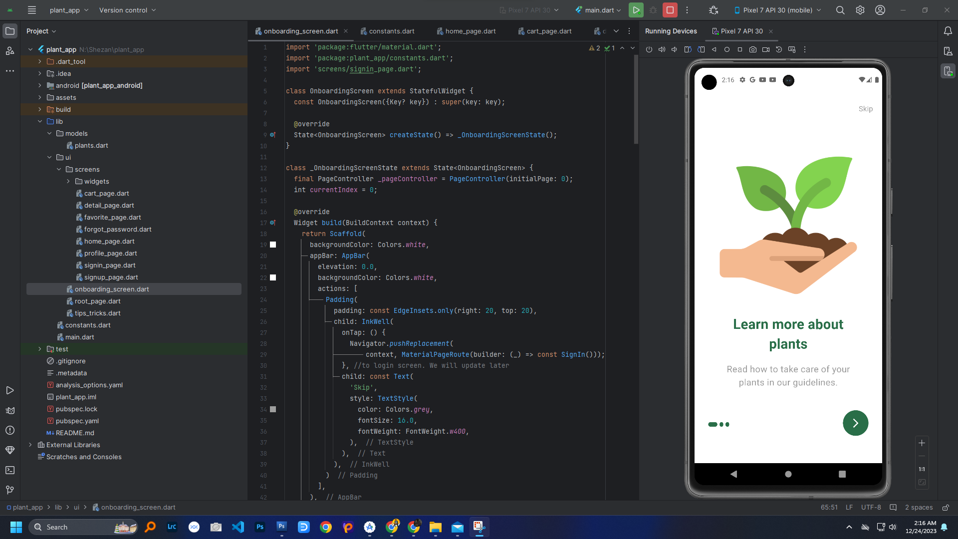

* Sign In

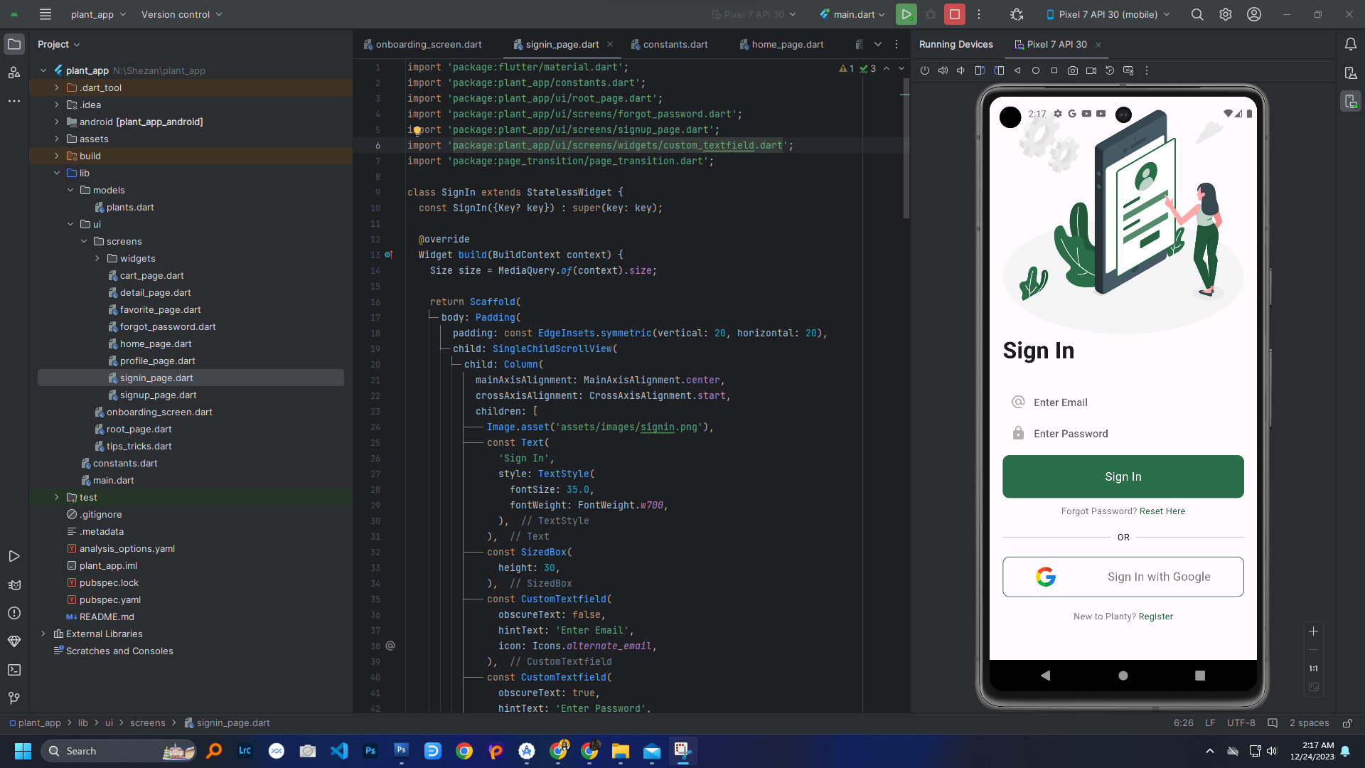

* Sign Up

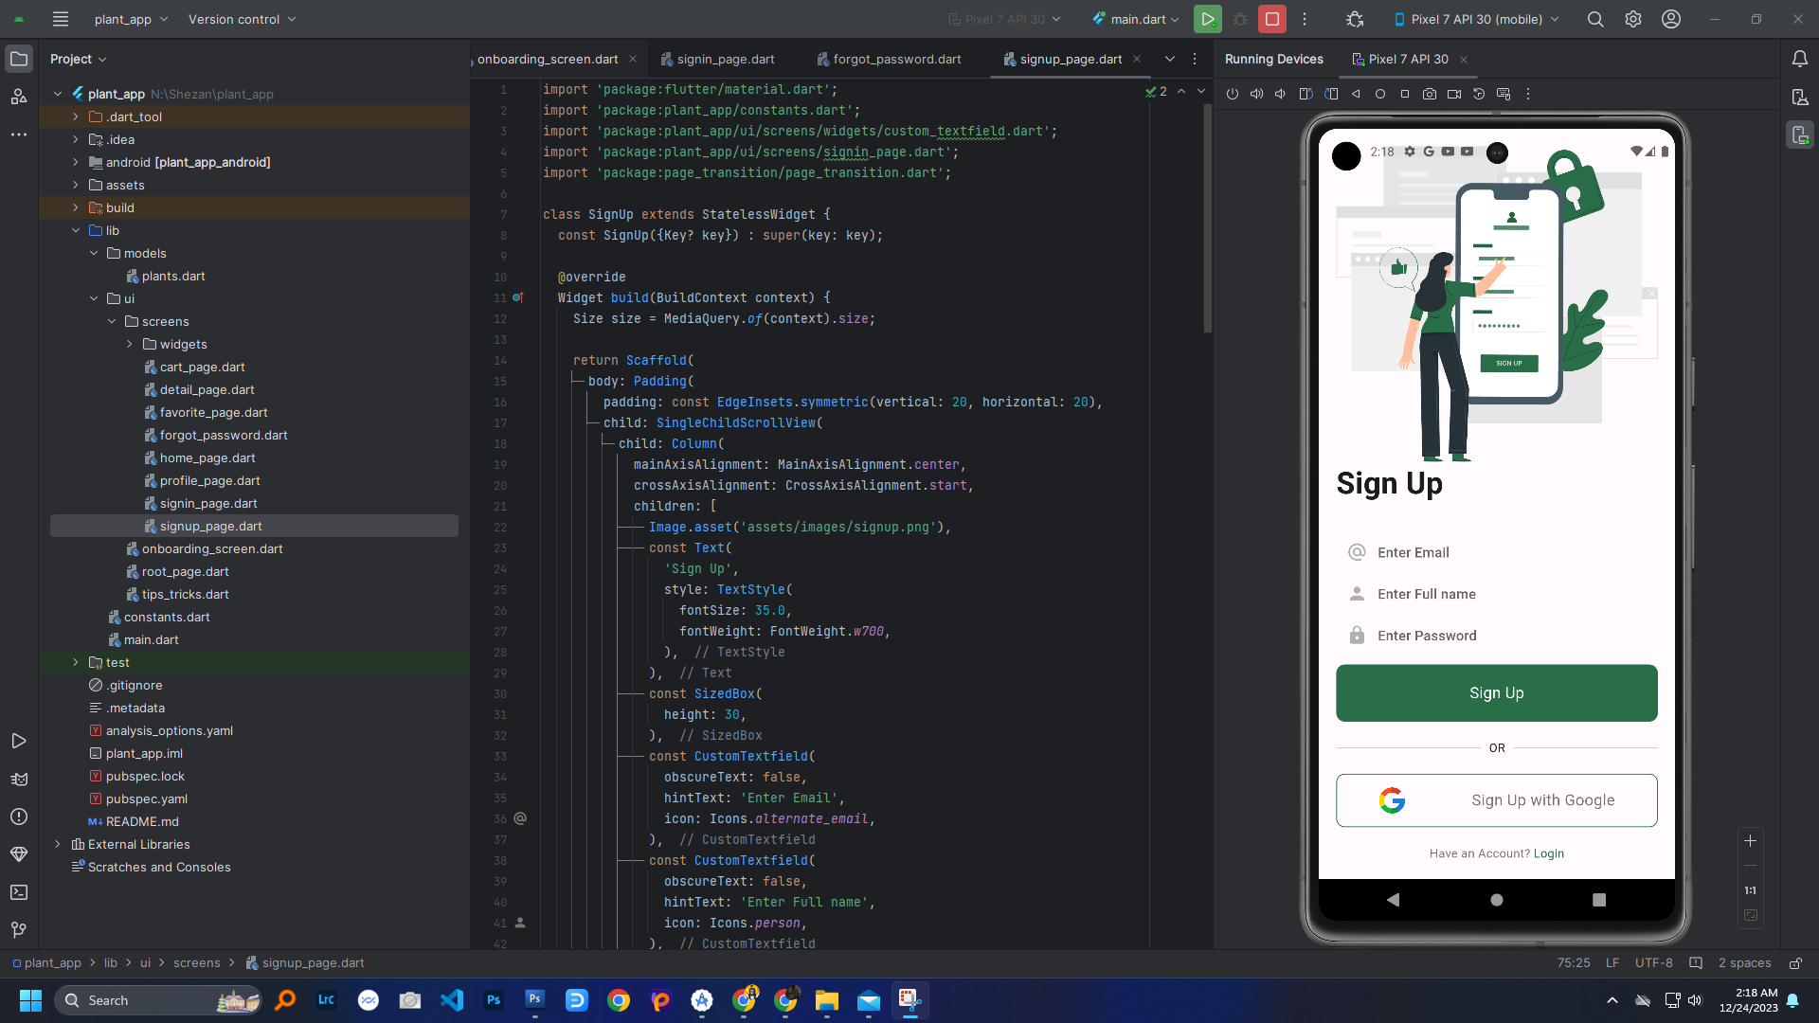

* Reset Password

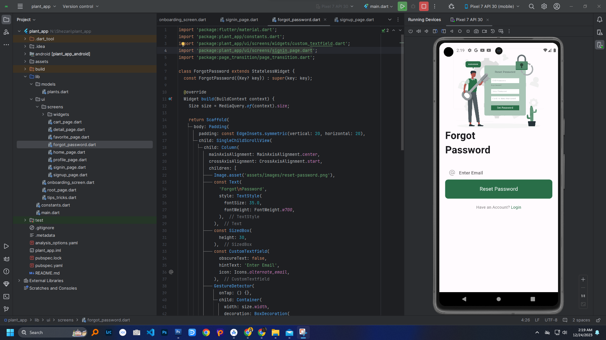

* Home Page

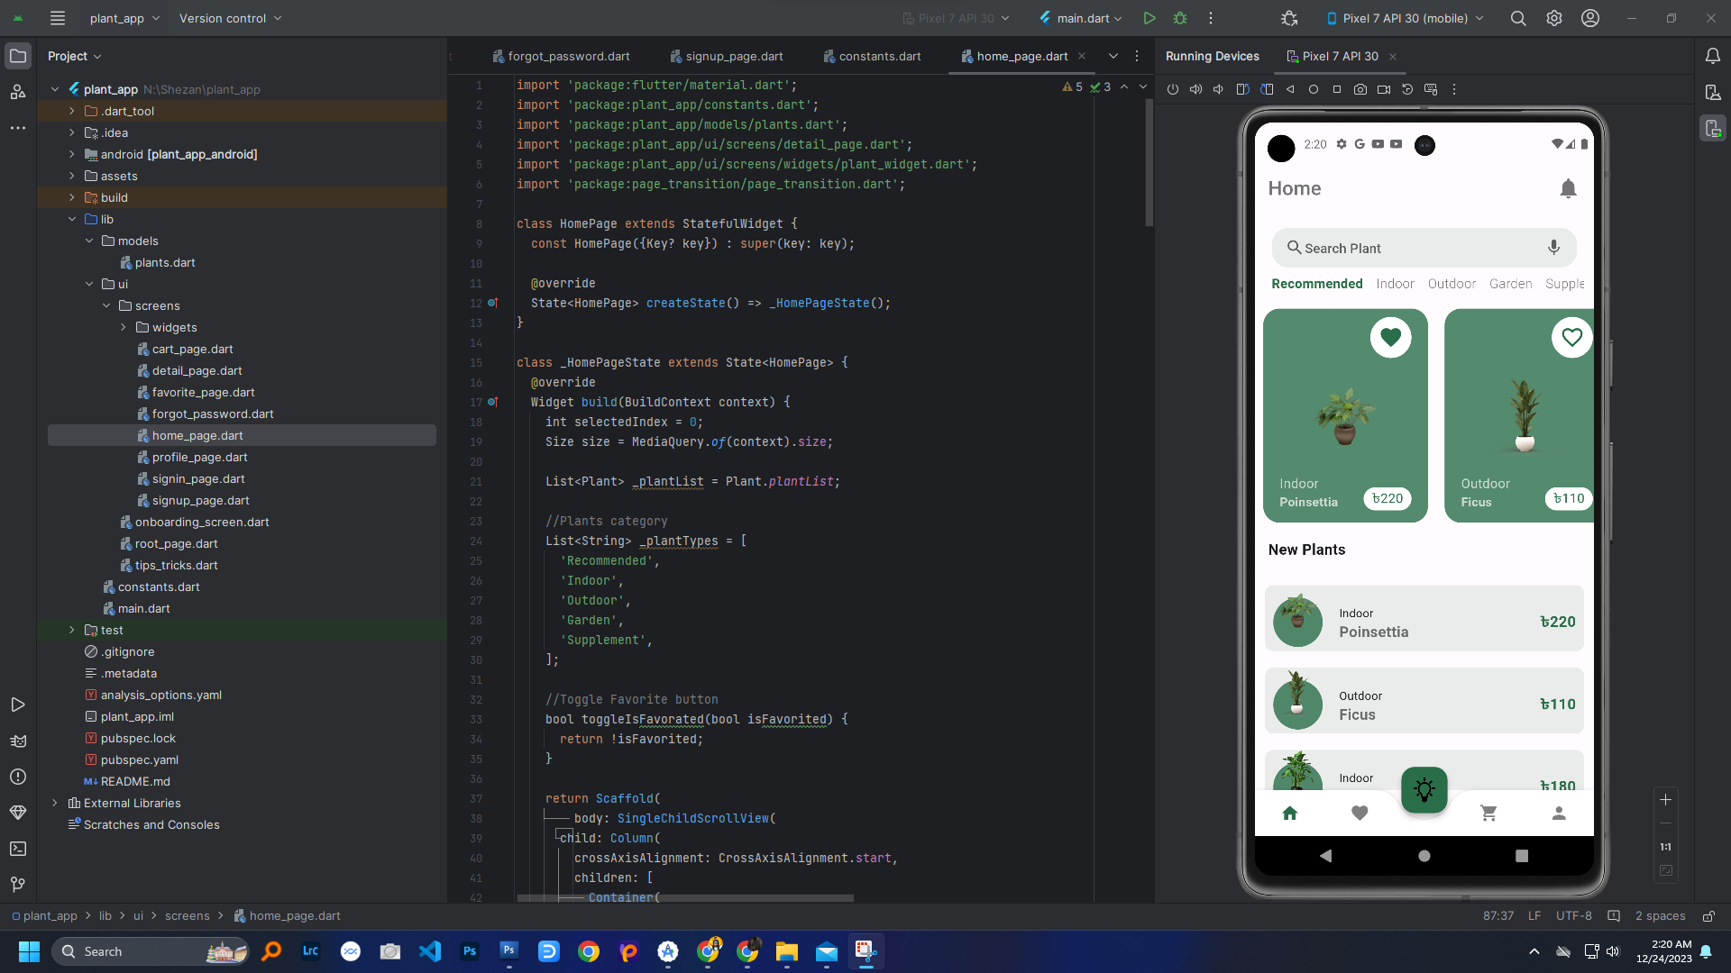

* Plant Details

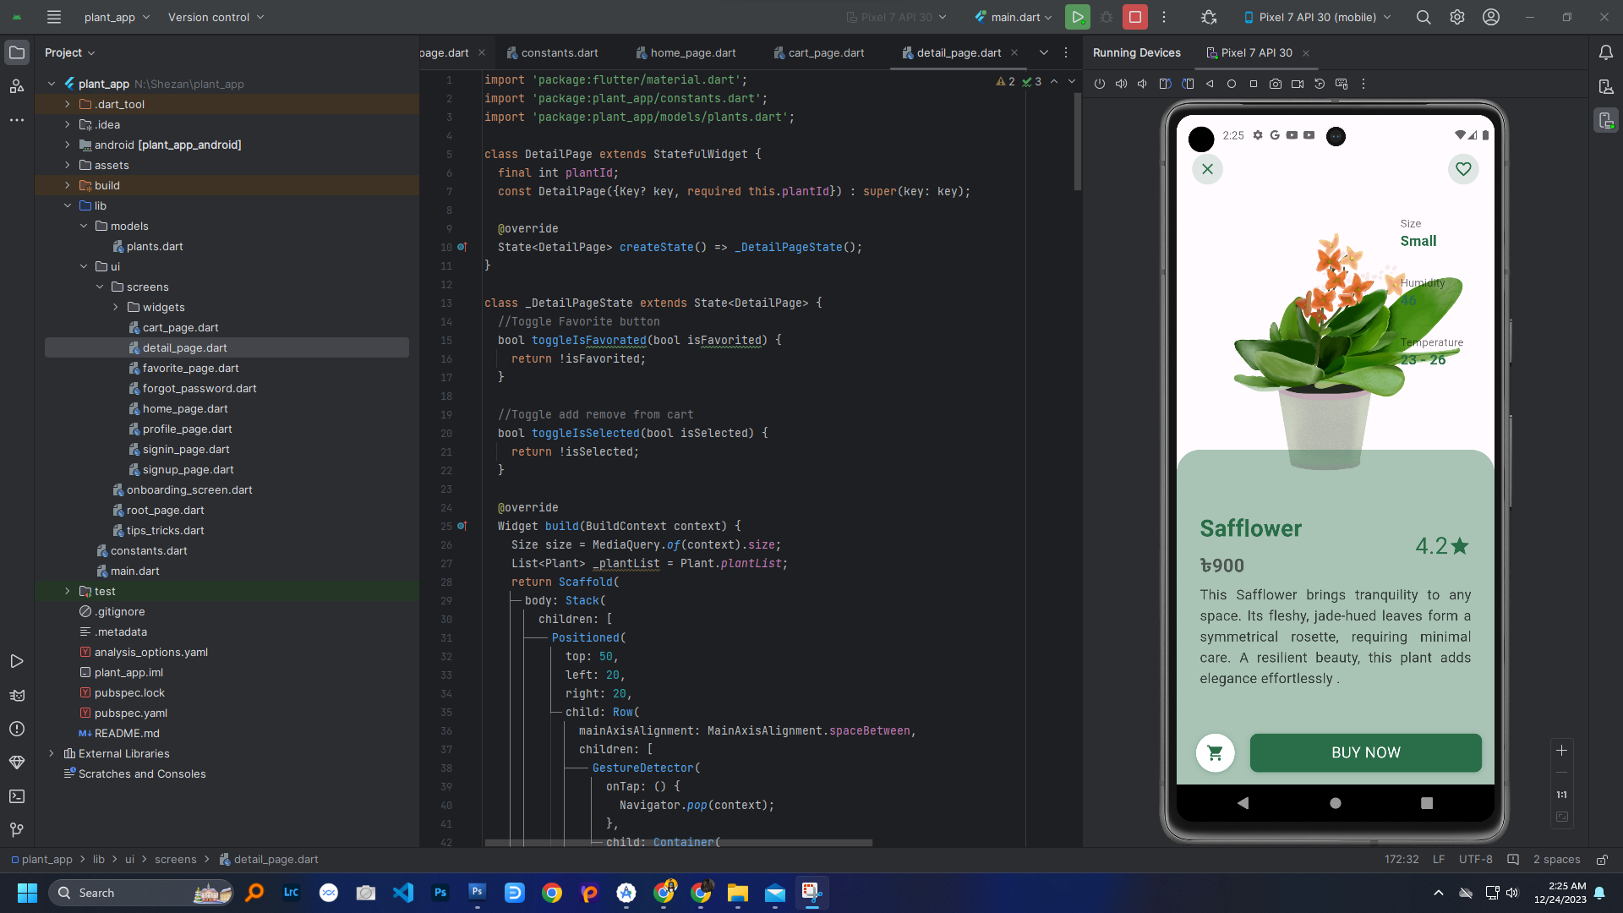

* Favourite

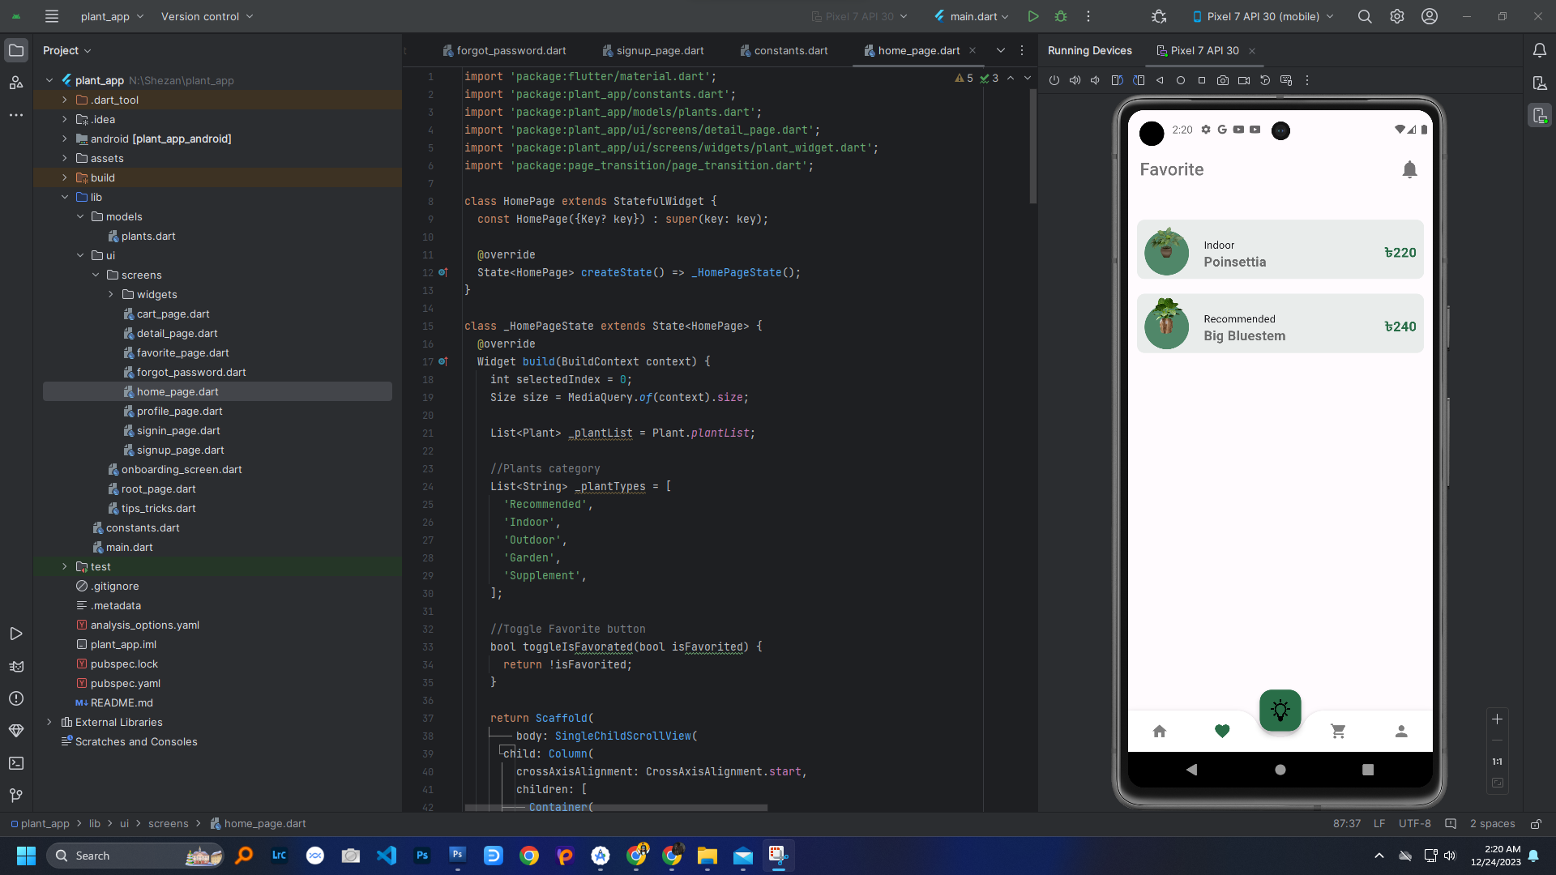

* Tips & Tricks

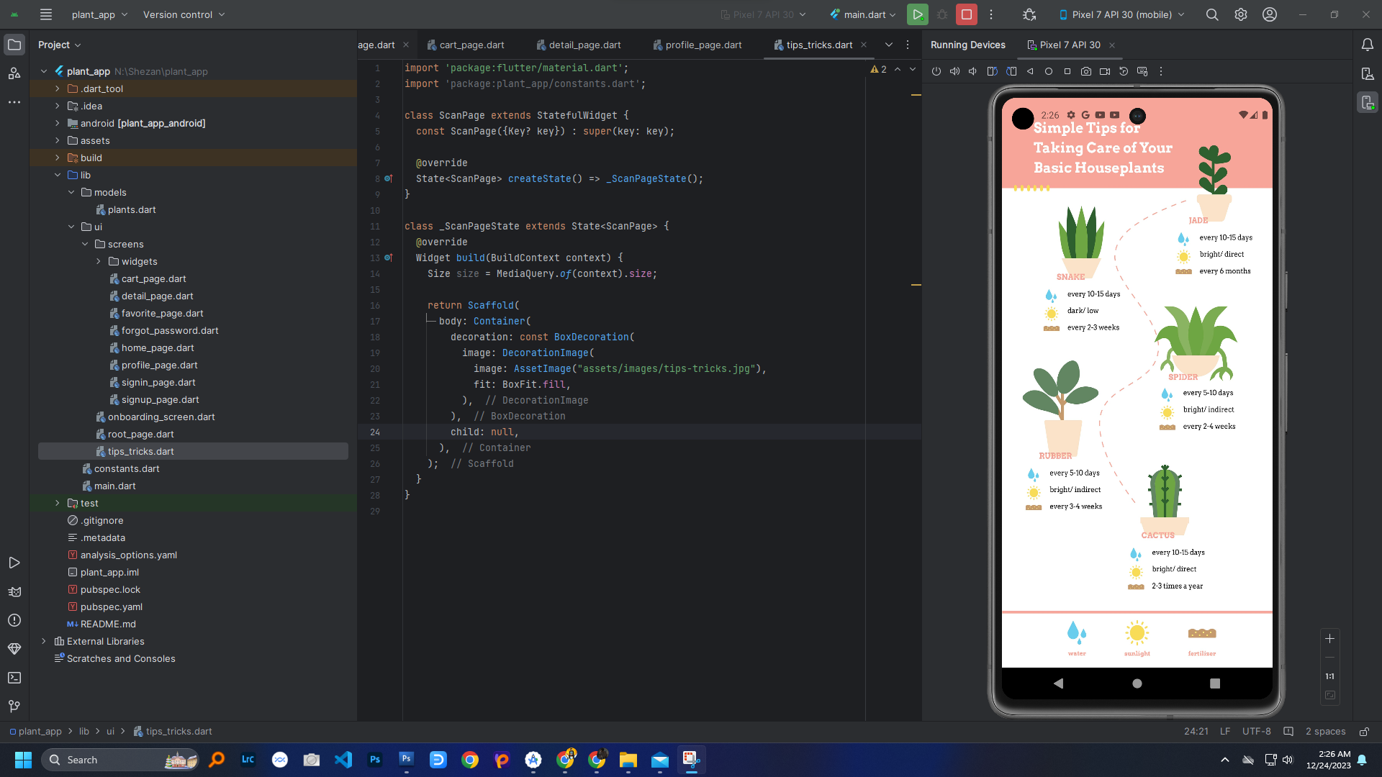

* Cart

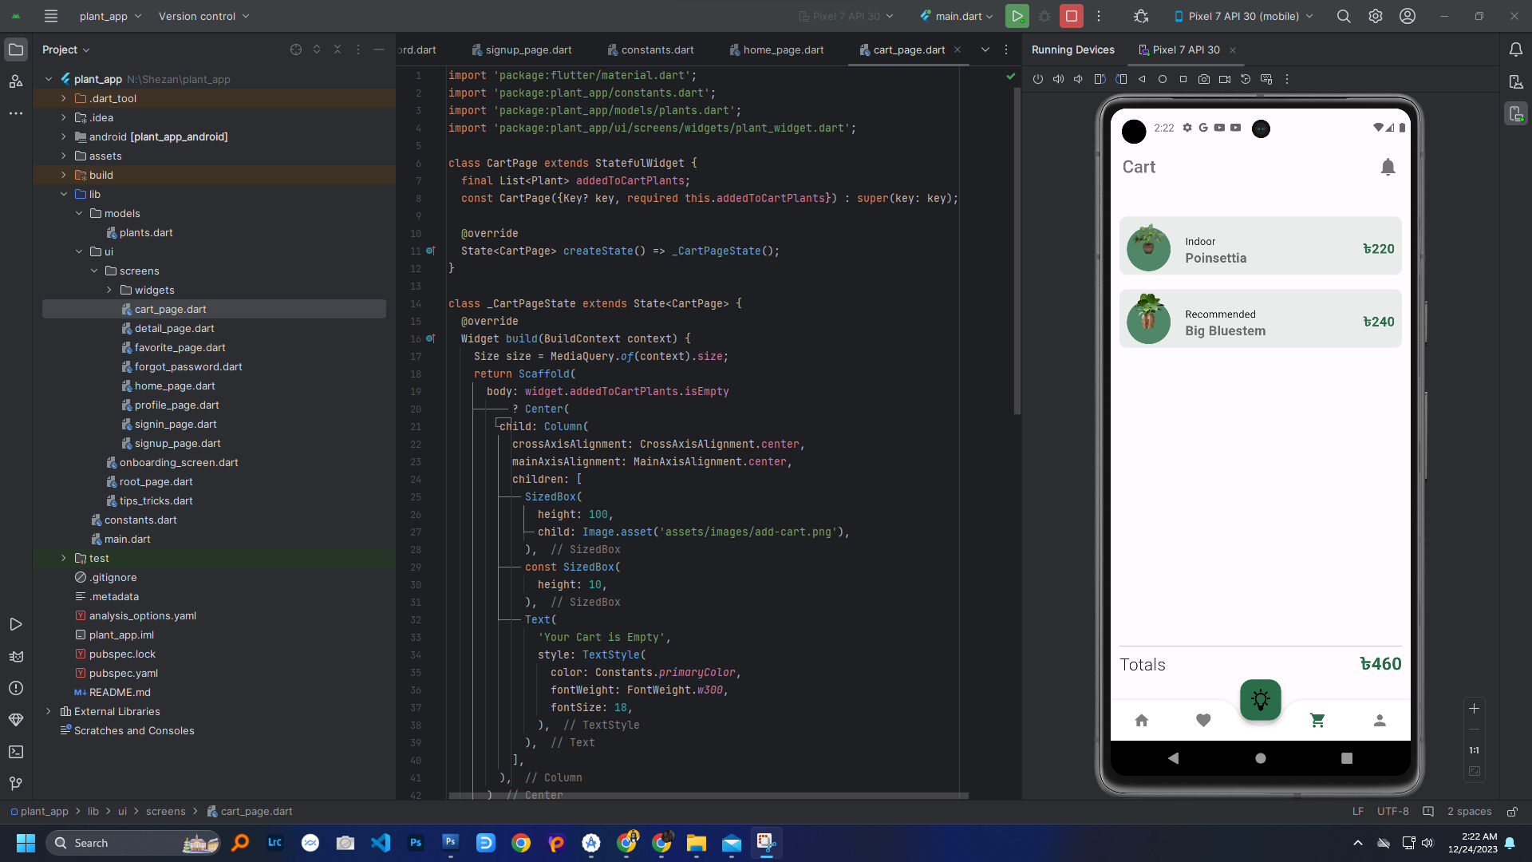

* Profile

